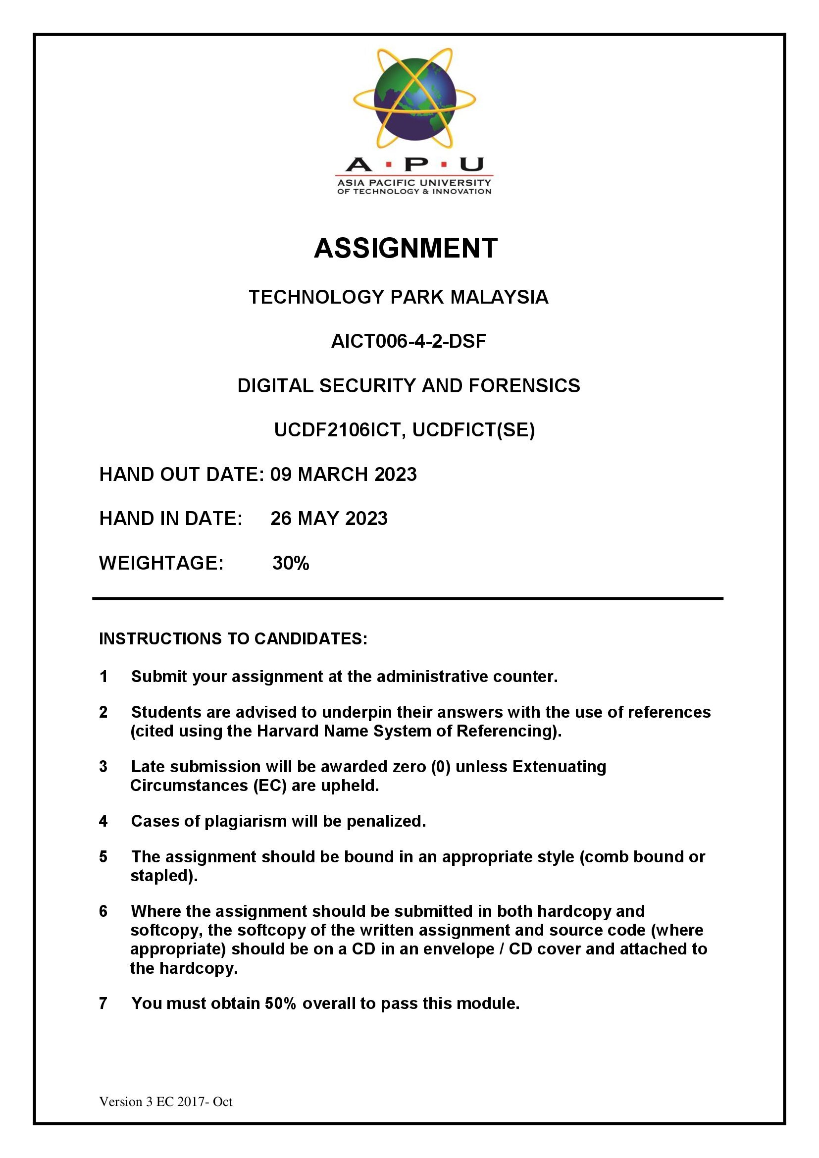

Table of Contents

Introduction 1

Data Acquisition 2

Hard Disk Image Technical Steps 3

RAM Image Technical Steps 7

Analysis 9

HDD Image 9

Discussion 9

Technical Steps 9

RAM Image 16

Discussion 16

Technical Steps 16

Report 20

HDD Image 20

Suspicious screenshots 20

Keylogger 21

KMSAuto 25

DLLInjector 27

Web Browser search 28

RAM Image 30

RSAWS.exe 31

WAP.exe 32

UW.exe 33

Conclusion 34

References 35

Appendix 36

Workload Matrix 36

Introduction

This report is written to discuss the forensics investigation conducted on the target machine, which is an infected Windows Server 2010. The objective of this investigation is to search for any possible malicious activities and look for evidence of malware that exists inside Windows Server 2010. Windows Server 2010 is accessed through VMware as a virtual machine. The investigation is started off by acquiring hard disk image and RAM image data by using a forensic tool named FTK imager. Analysis on the created image data will be carried out to look for suspicious activities that exists within the image data. Forensic tools used for analysis includes Autopsy, which is to analyse hard disk image and Volatility Workbench, which is to analyse RAM image. A summary report will then be written based on the results of analysis on the target system.

# Data Acquisition

In this forensic investigation, FTK Imager was selected as the tool for capturing HDD and RAM images from the infected PC. The reason behind this is that FTK Imager is a widely recognized and trusted forensic tool that offers several key features and benefits such as reliability, metadata and integrity verification as well as user-friendly interface. FTK Imager acquires the HDD image of the compromised computer, resulting in a reliable and bit-by-bit copy of the complete disk from a forensic perspective. The data on the disk, including file system structures, registry information, and deleted files, are all captured during this picture acquisition, which is crucial for analysing thorough forensic investigation. On the other side, the RAM acquisition makes sure that volatile data is recorded, such as active processes, active network connections, and loaded drivers, which might give important information about the system's condition at the time of infection. Following are the technical steps for capturing HDD and RAM images. (THOMAS, 2022)

## Hard Disk Image Technical Steps

Step 1: Connect an external drive to the victim machine.

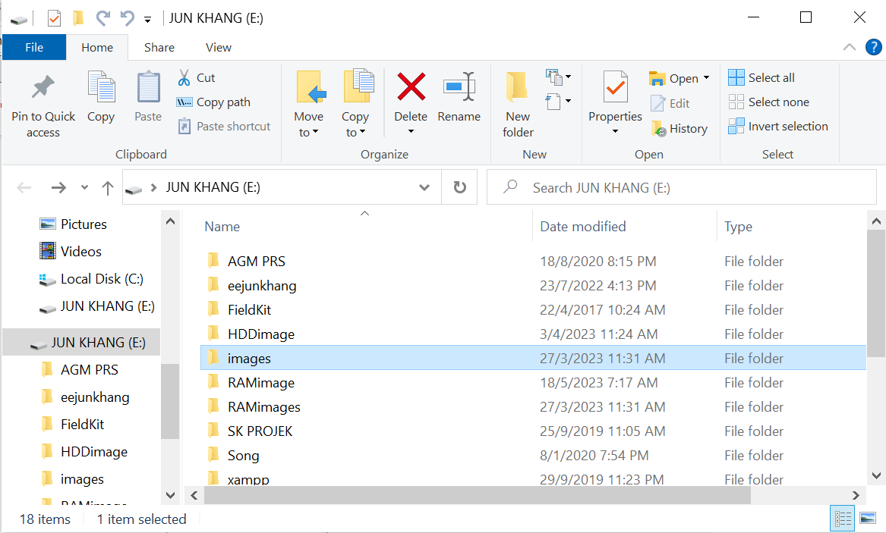

Figure 1: External Drive (Pen drive)

A pen drive was connected to victim machine for storing the original captured image to prevent any modification of the original evidence.

Step 2: Launch FTK Imager

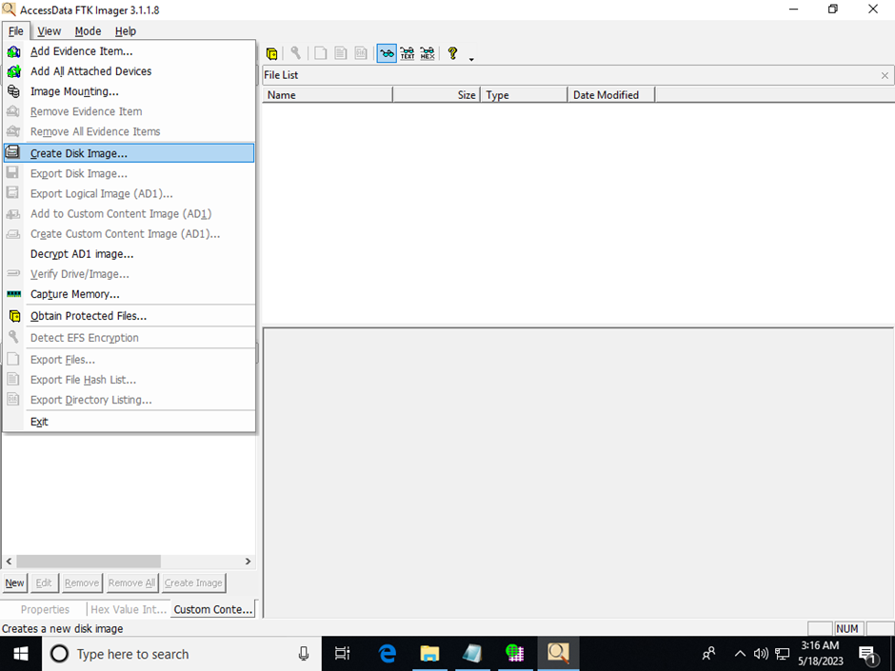

Figure 2 2: FTK Imager File Tab

After opening FTK imager, under the file tab in the top left corner, select the create Disk Image to capture hard disk image.

Step 3: Select Source of Evidence Type

Select Physical Drive, this is the primary storage hardware or the components within a device where we need to capture the images of the hard disk.

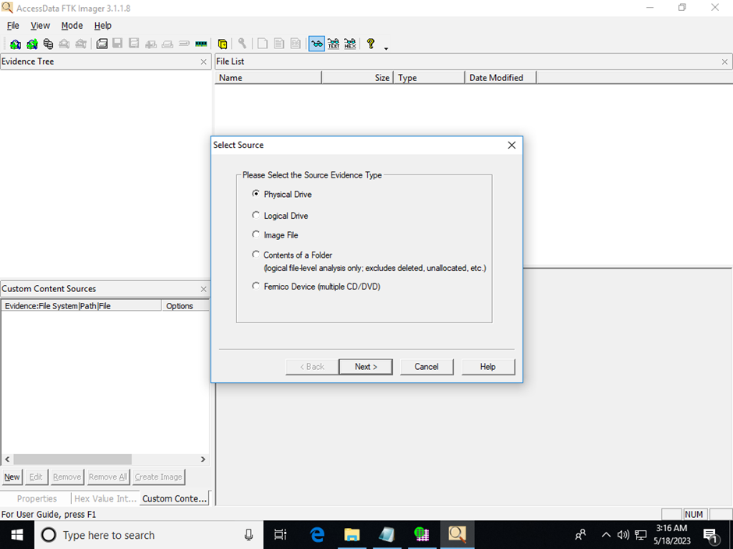

Figure 3 3: Select Source

Step 4: Select Data Image Type

Select E01, this is the commonly used format of hard disk imaging.

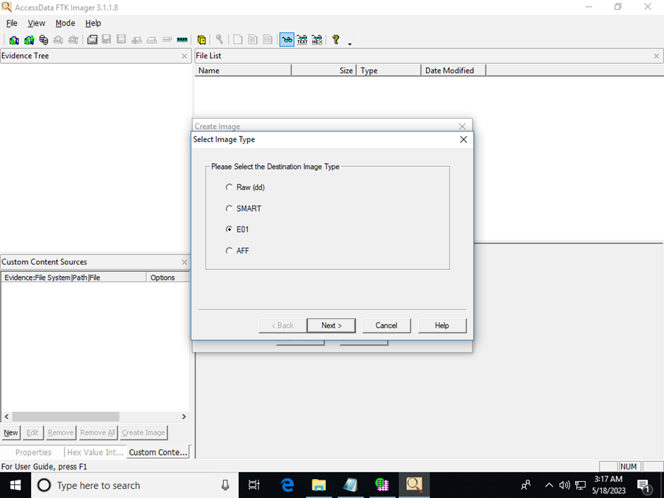

Figure 4 4: Select Image Type

Step 6: Insert relevant evidence information of the image captured.

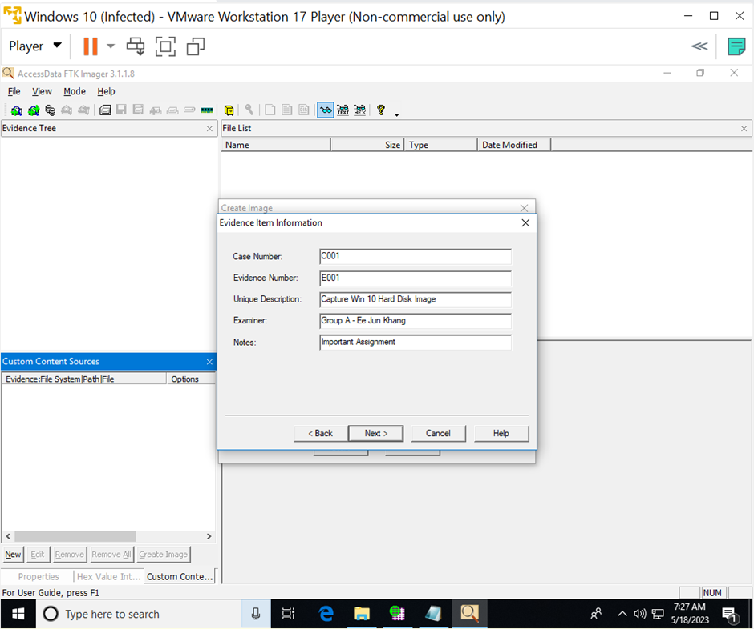

Figure 5 5: Evidence Item Information

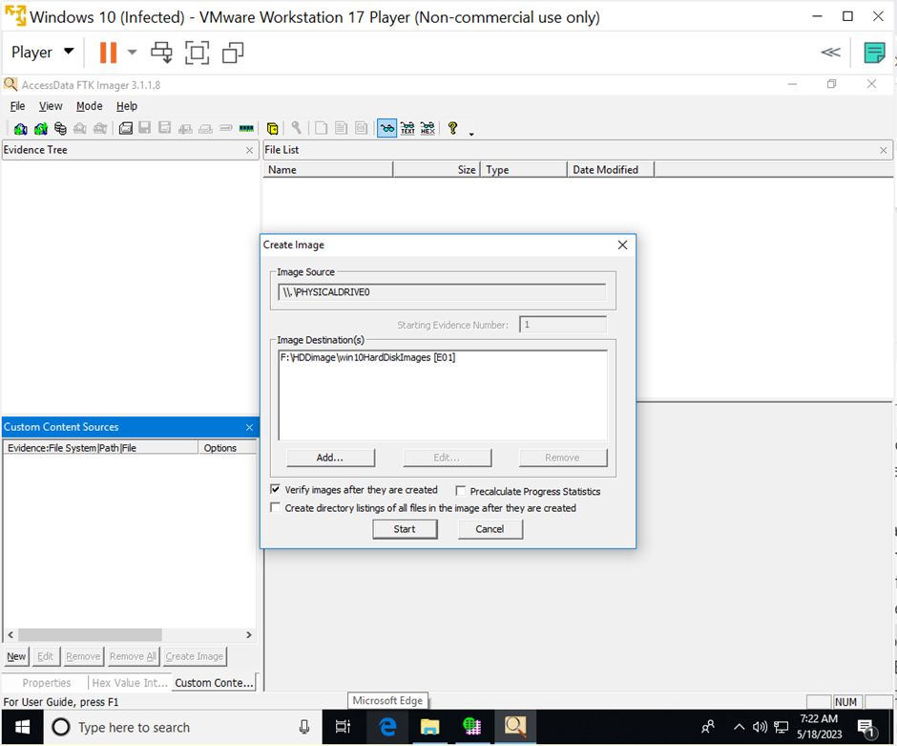Step 7: Select Image Destination

Figure 6 6: Create Image

Select the directory of the external drive that has inserted before. Name the image file with appropriate name. The captured image is stored in an external drive (pen drive) for analysis purpose.

Step 8: Start capturing images and wait for the image capturing process.

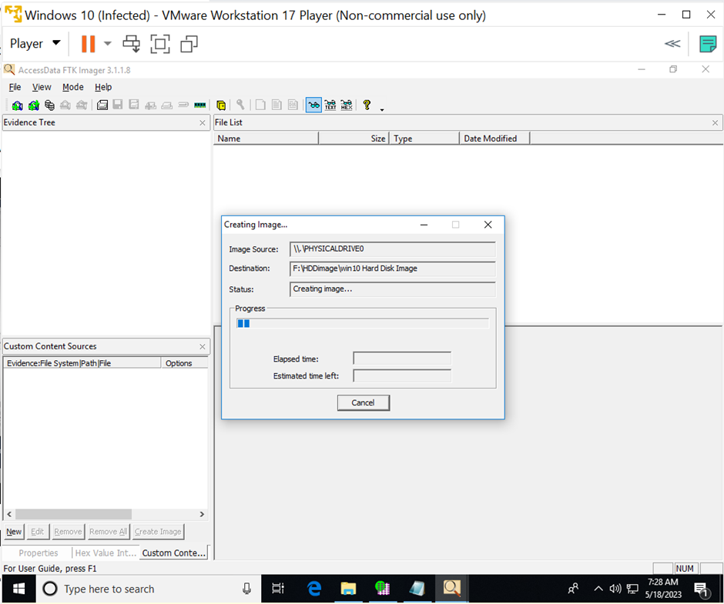

Figure 7: Process Create Image

## RAM Image Technical Steps

Step 1: Capture Memory

By using the connected external drive from hard disk imaging, launch FTK imager, and click on capture memory to begin RAM imaging under the file tab.

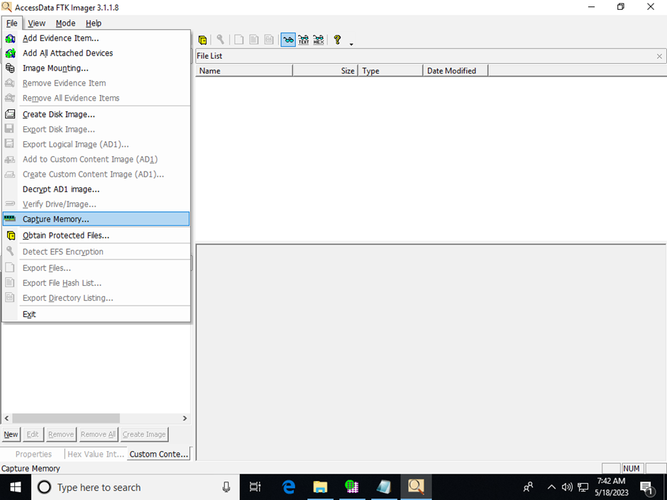

Figure 8: FTK Imager File Tab

Step 2: Choose Destination Path

Fill in the destination path that you want to store the RAM image in and create the destination filename. After that, click on capture memory to start the RAM imaging process.

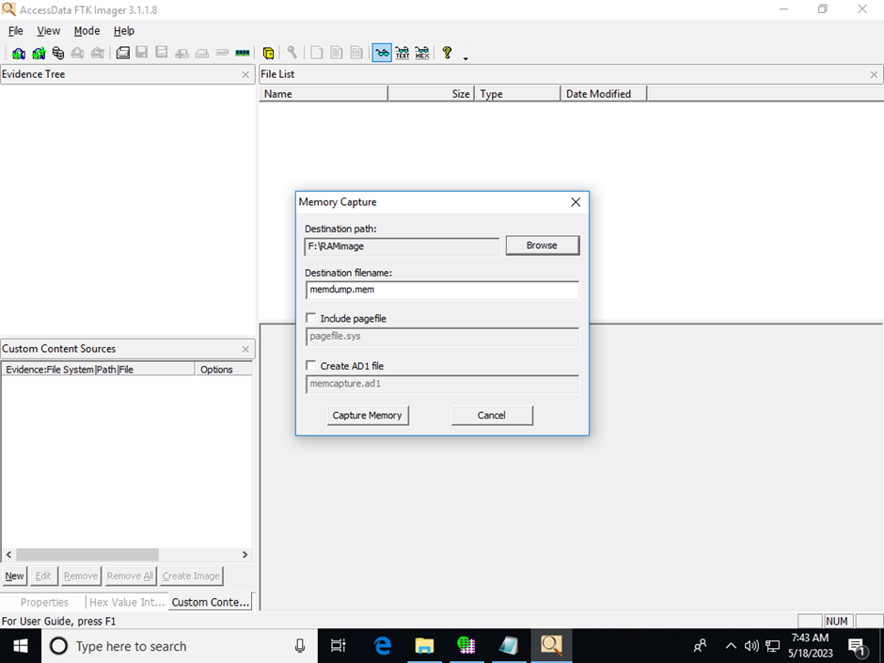

Figure 9: Memory Capture

Step 3: Start Capturing RAM images and wait for RAM image capturing process.

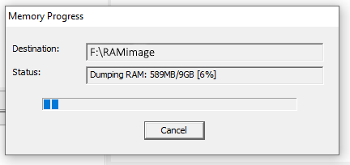

Figure 10: Memory Progress

# Analysis

## HDD Image

### Discussion

In order to analyse the target machine properly and safely, we had previously imaged its hard-disk and stored it within a forensically clean external drive for accessing the hard disk image. So now we will use a forensics analysis tool called Autopsy from TheSleuthKit to thoroughly analyse the compromised Windows Server 2010’s disk image. And inspect areas like its browser history, running processes, images.

### Technical Steps

#### Test case setup

STEP 1: Creating a new test case.

First and foremost, we must launch autopsy and create a new test case, as well as configure its location to be stored.

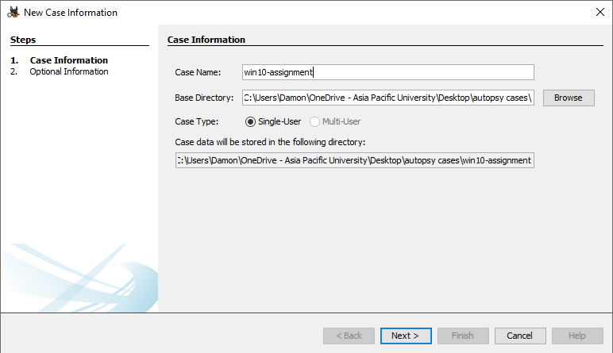

Figure 11 Test case setup step 1.

STEP 2: Additional details.

As for specifying the examiner, we fill out our contact details.

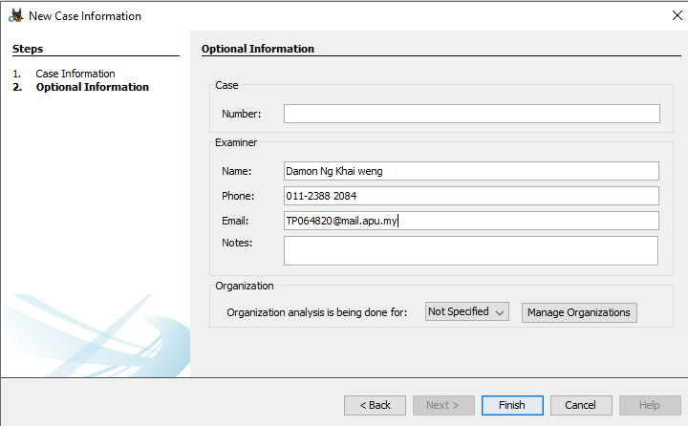

Figure 12 Test case setup step 2.

STEP 3: Initializing data source.

After autopsy finishes setting up a test case, its time to use our data source within the external drive. First, we will generate a host name for it.

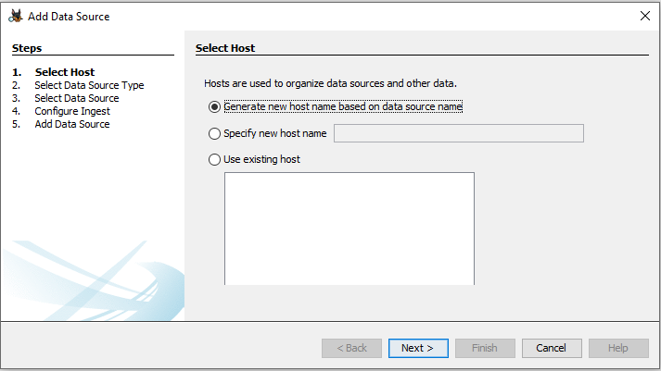

Figure 13 Test case setup step 3.

STEP 4: Declaring data source type.

Since our data source is a disk image, we will choose disk image or VM file as the data source type.

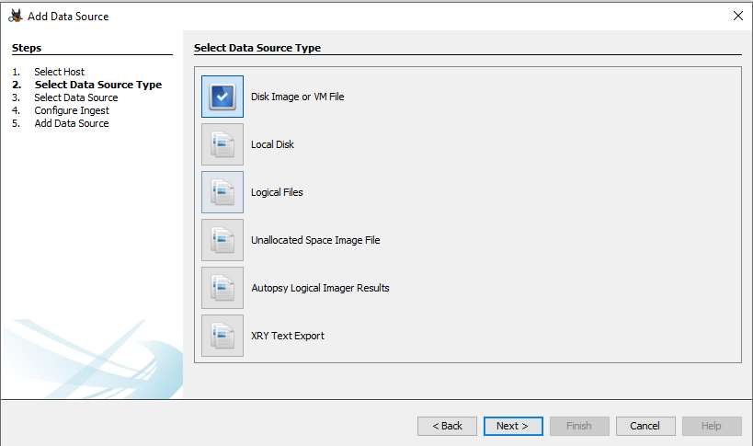

Figure 14 Test case setup step 4.

STEP 5: Locating data source.

Then we will locate the data source within our drive and use it for our analysis.

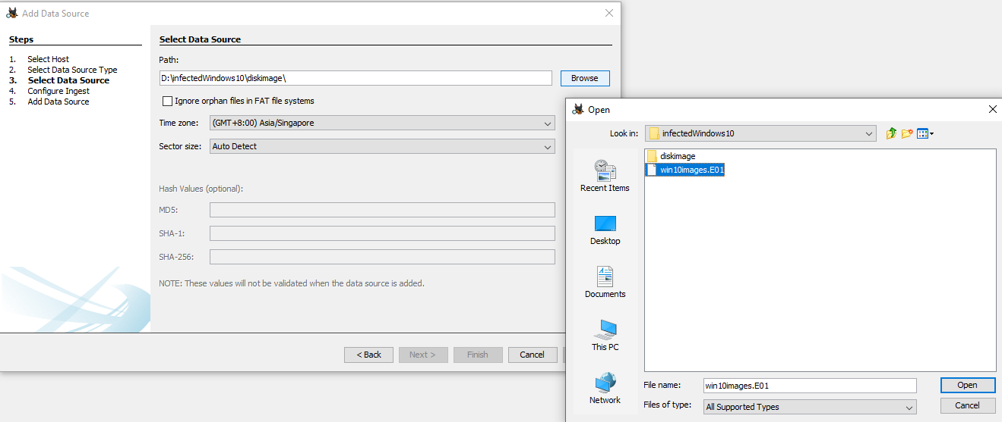

Figure 15 Test case setup step 5.

STEP 6: Configure ingest:

Configure the ingest module for file analysis.

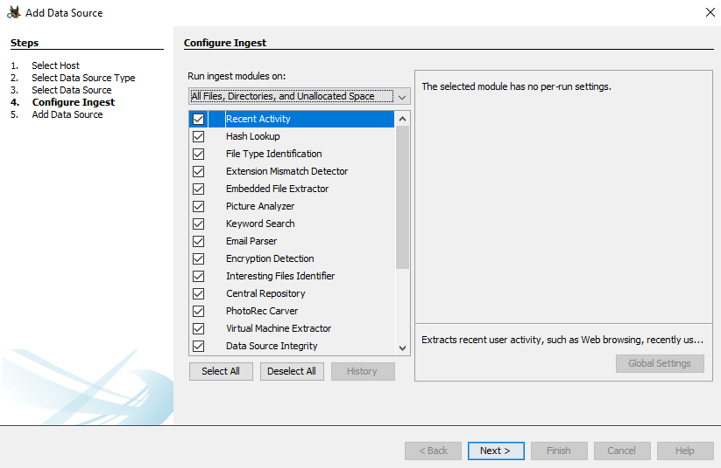

Figure 16: Add data source

STEP 7: Wait until finish.

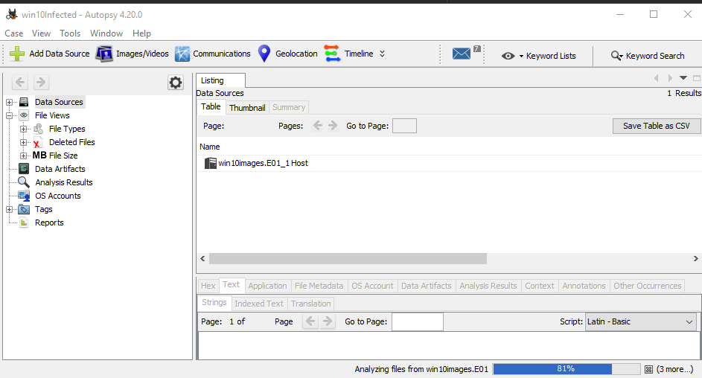The progress bar at the bottom right indicates each analysis of the data source. Take a break and wait until all of them finishes.

*Figure 17: Data sources*

#### Analysis by sections

STEP 1: Check images.

After the analysis by the ingest module is complete, start by checking file views, file types, by MIME types, images, jpeg for any suspicious images.

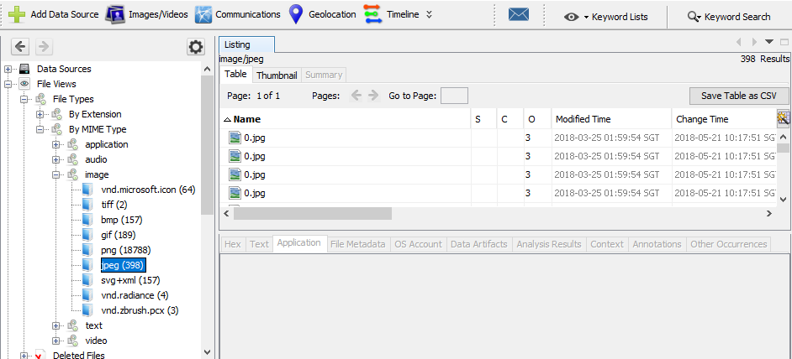

Figure 18 Checking images.

STEP 2: Check recent documents.

After checking for any malicious images stored in the disk image, navigate to data artifacts, recent documents to check for any malware that were recently triggered.

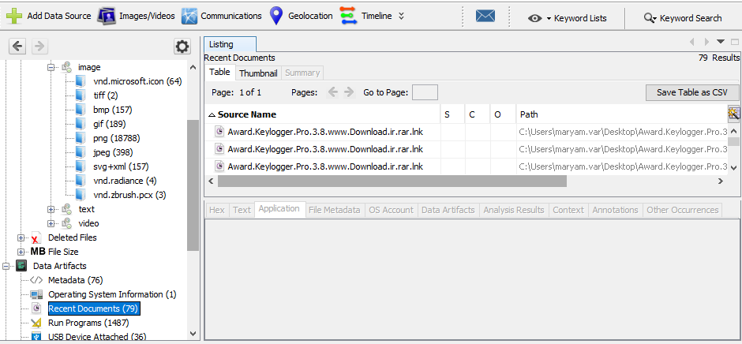

Figure 19 Checking recent documents.

STEP 3: Check for running programs:

Then, navigate to data artifacts, run programs to check for any malware that were running when the disk image was captured.

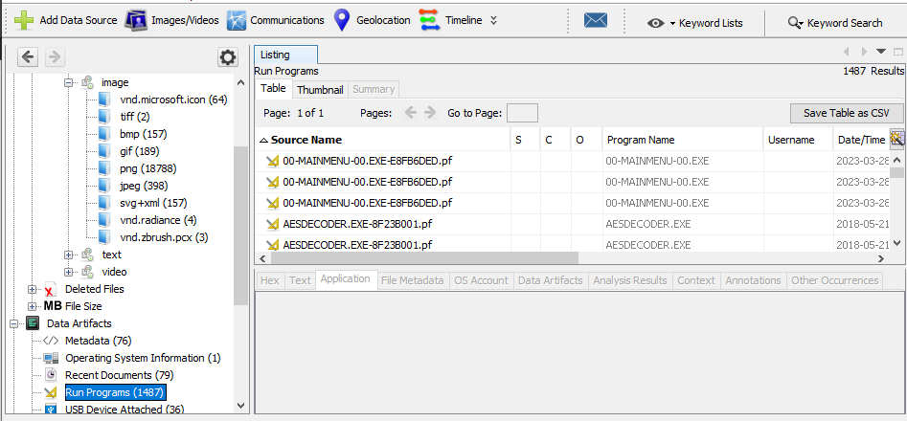

Figure 20 Checking running processes.

STEP 4: check for web cookies and histories:

After that, navigate to data artifacts, web cookies and web downloads and search history to look for any suspicious web activities stored in the HDD image.

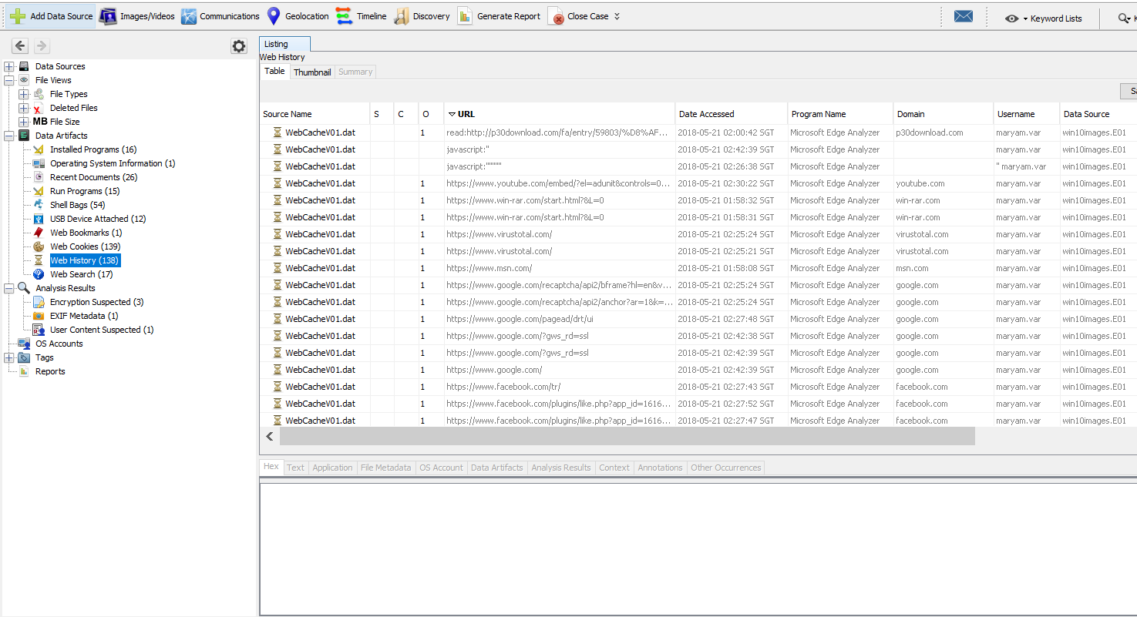

Figure 21 Checking Web history

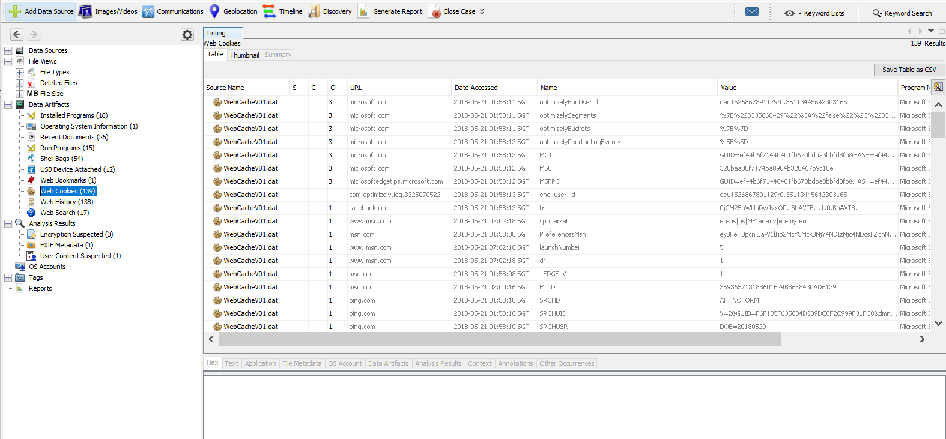

Figure 22 Checking Web cookies

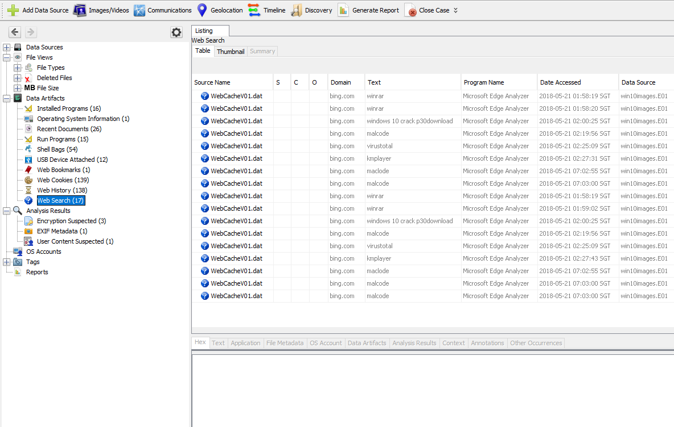

Figure 23 Checking Web Searches

## RAM Image

### Discussion

The acquired RAM image was loaded into a removable flash drive for analysis. Volatility Workbench by PassMark Software was used to conduct the analysis towards the RAM image. Various volatility plugins were utilized to examine processes, network connections, and other volatile data. Findings included suspicious processes, network connections to malicious IP addresses, and potential IOCs.

### Technical Steps

Step 1: Start up Volatility Workbench as Administrator

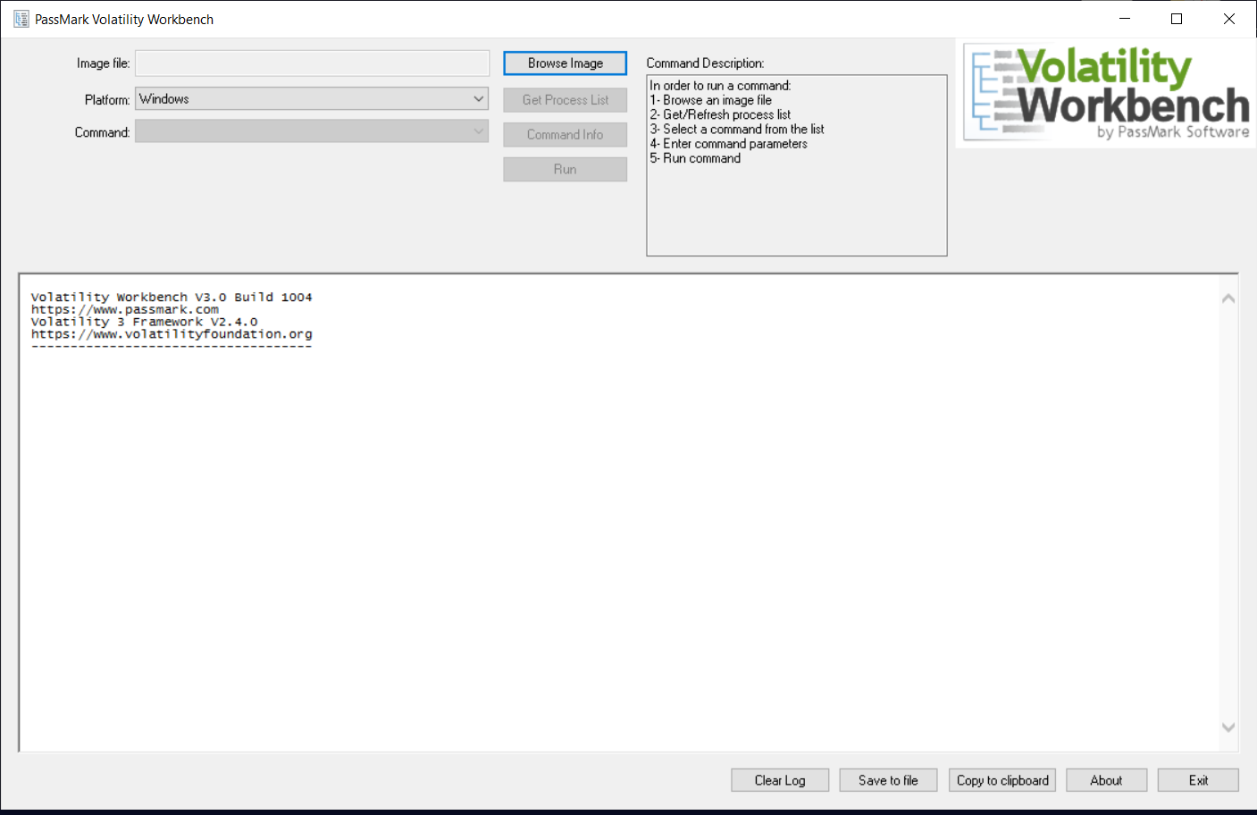

Figure 24 RAM Analysis Step 1

Start the volatility workbench as administrator is important to avoid permission-related errors when using the application. By granting administrator privileges, it can ensure that the application runs smoothly and has more allocated resources to support the function.

Step 2: Click “Browse Image”

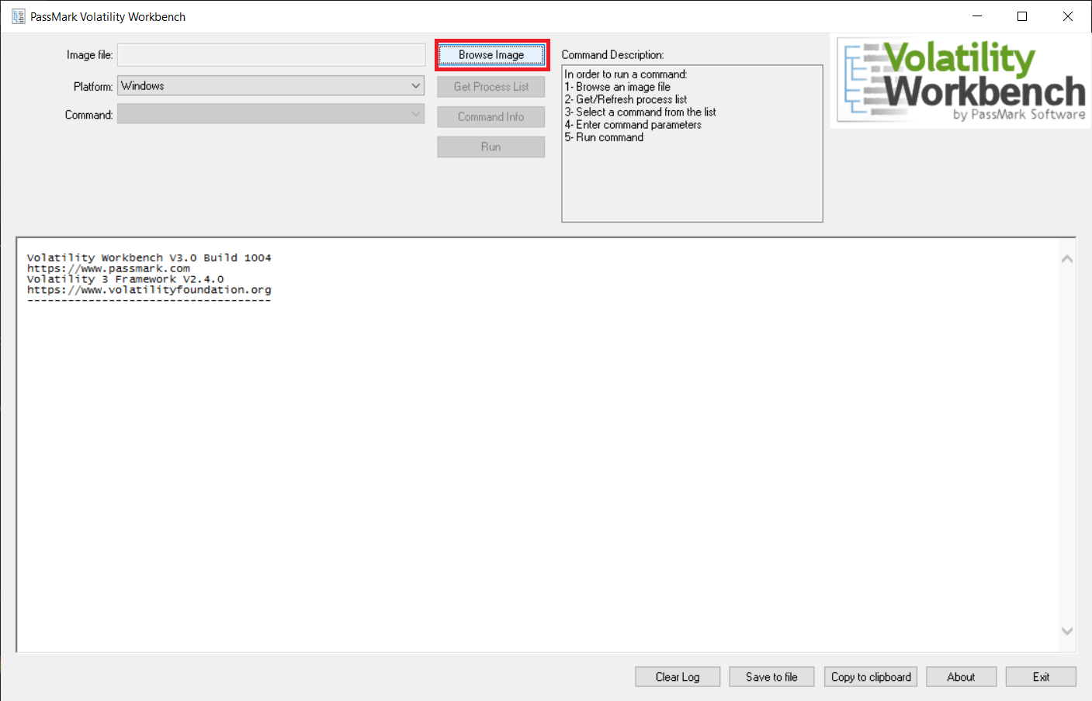

Figure 25 RAM Analysis Step 2

After starting volatility workbench, click on the “Browse Image” button to open the file explore to open the image.

Step 3: Select the memory image file.

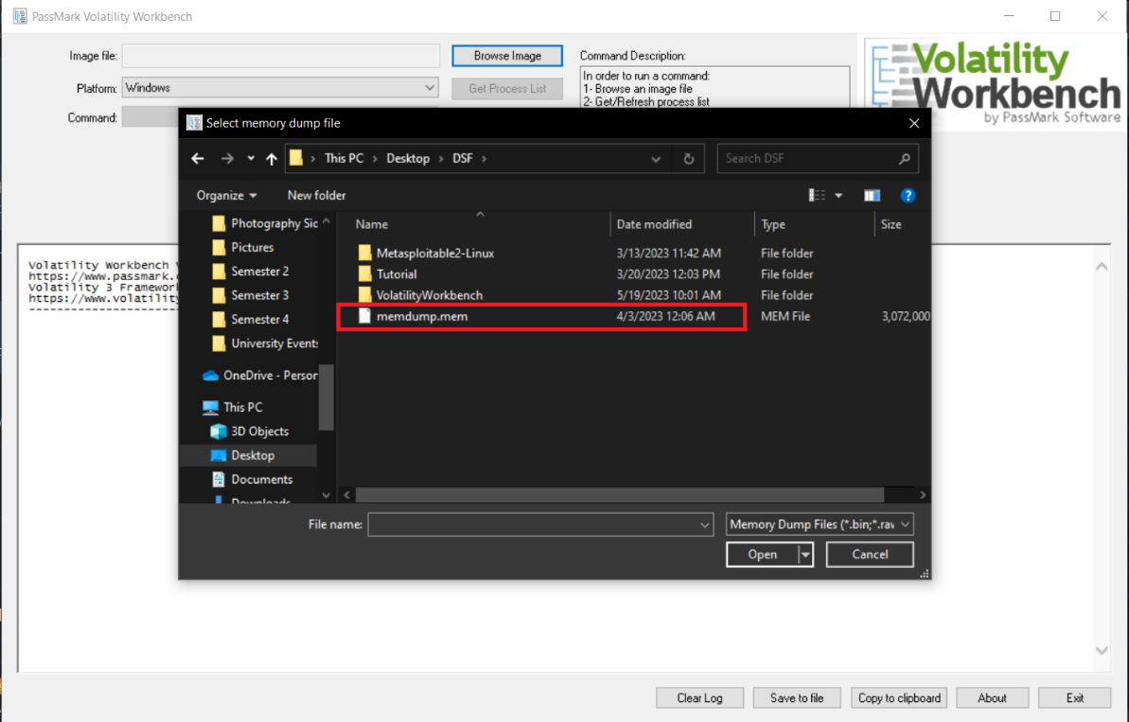

Figure 26 RAM Analysis Step 3

Navigate to the folder where the RAM image is stored and click “Open” to open the image within volatility workbench.

Step 4: Click “Refresh Process List”

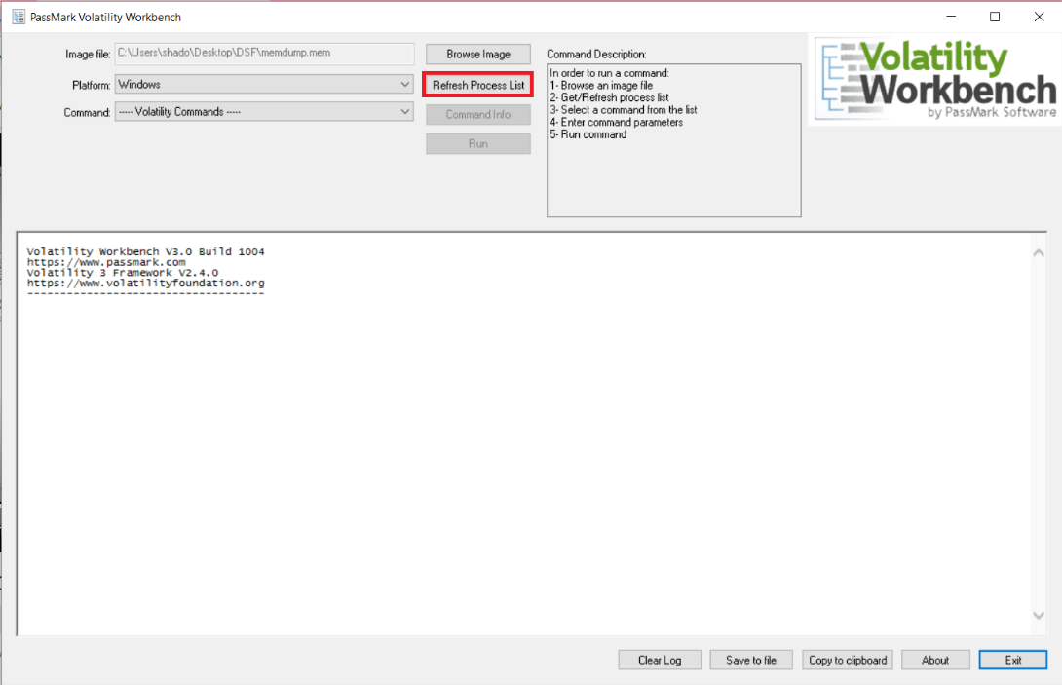

Figure 27 RAM Analysis Step 4

After the image is selected within the volatility workbench, click “Refresh Process List” to retrieve the latest information about the processes within the RAM image.

Step 5: Start to identify for vulnerability.

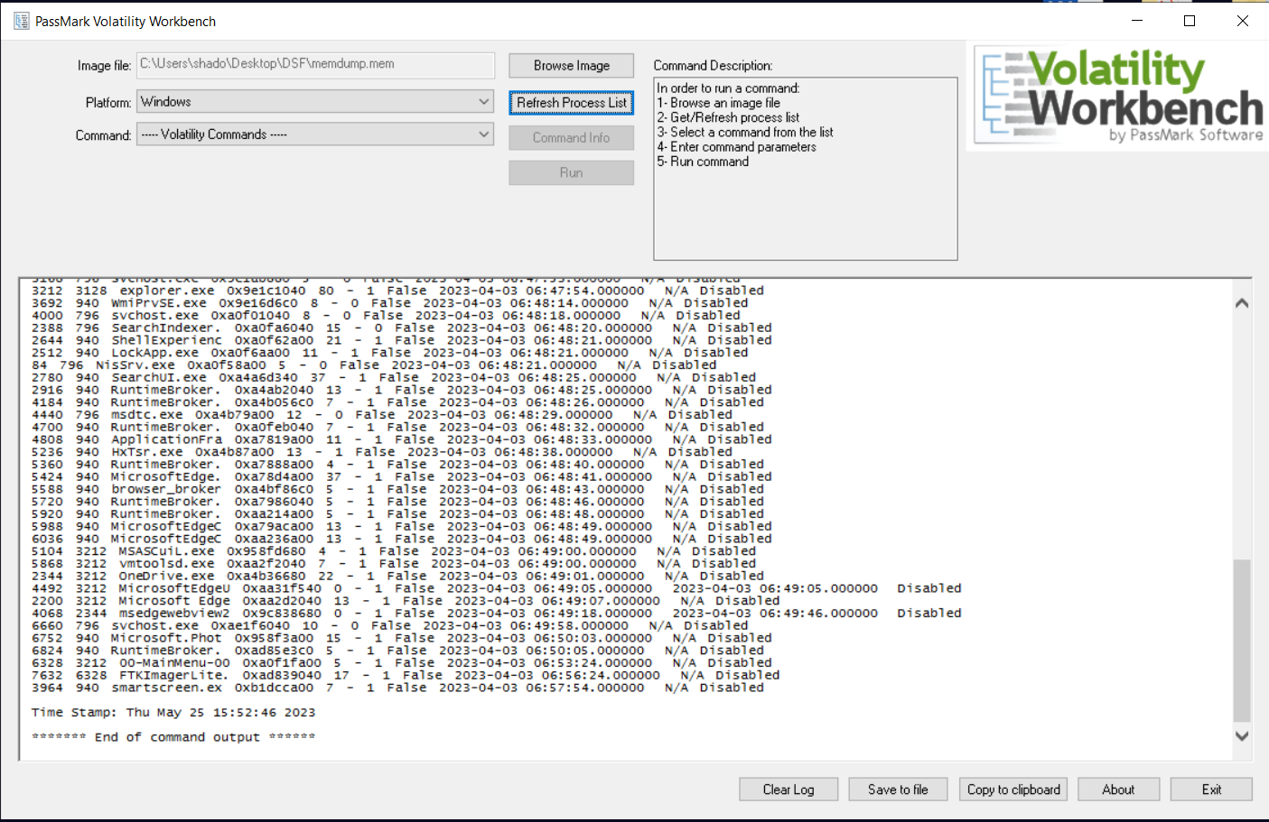

Figure 28 RAM Analysis Step 5

After the processes finish loading, the user can start to analyse the image for vulnerabilities in the RAM image.

# Report

## HDD Image

### Suspicious screenshots

To find the suspicious screenshots, head over to file views, after that click file types, by MIME type, jpeg. It will show all the suspicious screenshots that were taken of the entire frame of the target machine. The images were not taken by data gatherer which means it is automatically taken by an unknown software.

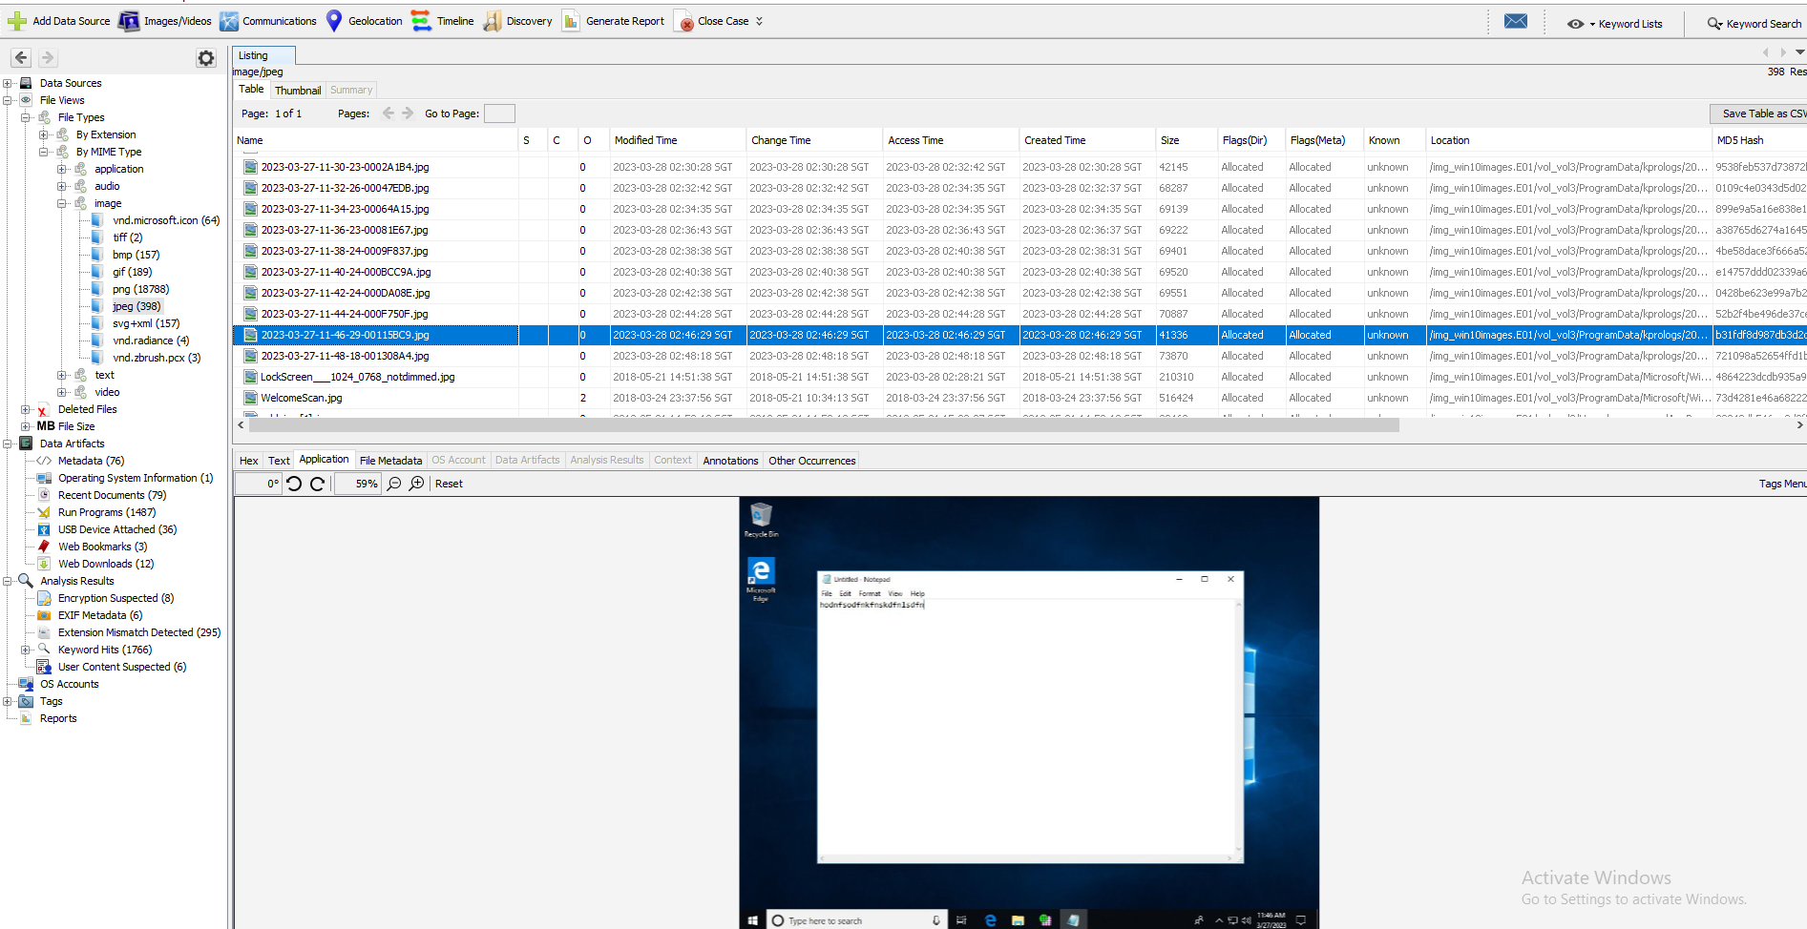

Figure 29A group of suspicious screenshots

### Keylogger

There were signs that a keylogger had been planted in the computer. The keylogger evidence can be found within data artifacts > recent documents and run programmes. Since it is a trojan keylogger, it was most likely bundled within software that were downloaded from questionable websites. Our analysis also shows that this trojan keylogger utilizes subprocesses named SETUP.exe, BUILDER.exe, UW.exe, RSAWS.exe and WAP.exe As for what is a keylogger, it is a software used to record keystrokes of user operating the victim machine. These captured keystrokes will then be sent to the attacker who planted the keylogger within the victim machine. (Keyloggers: How They Work and How to Detect Them, 2023; Trojan.KeyLogger.25094, 2015) Based on the file directory of the suspicious images found previously, it is also possible that this keylogger is able to anonymously capture the entire screen and sent it to its attacker as well. Because of this, the malware can possibly cause the target machine’s user to become a victim of identify fraud and information theft.

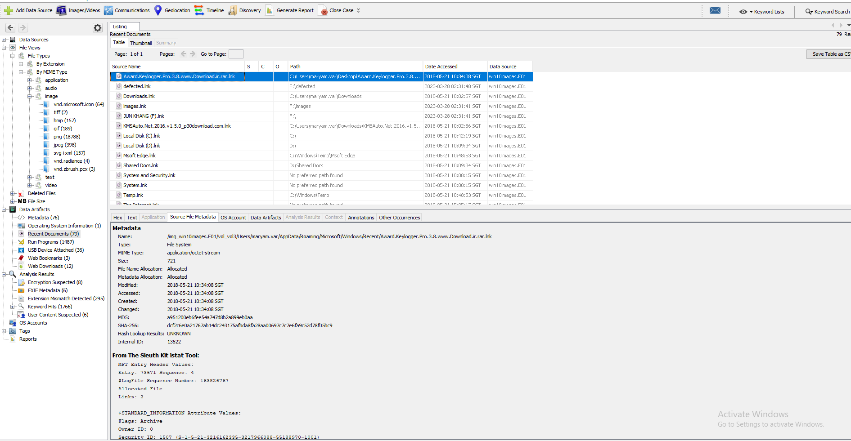

Figure 30 Keylogger download shortcut.

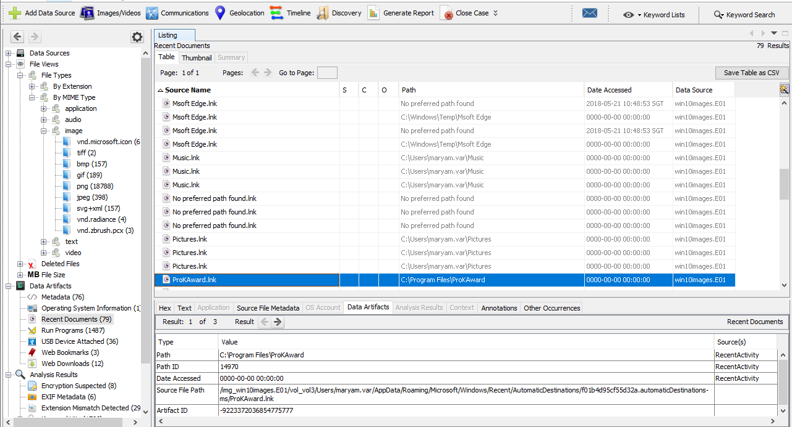

Figure 31Keylogger shortcut file

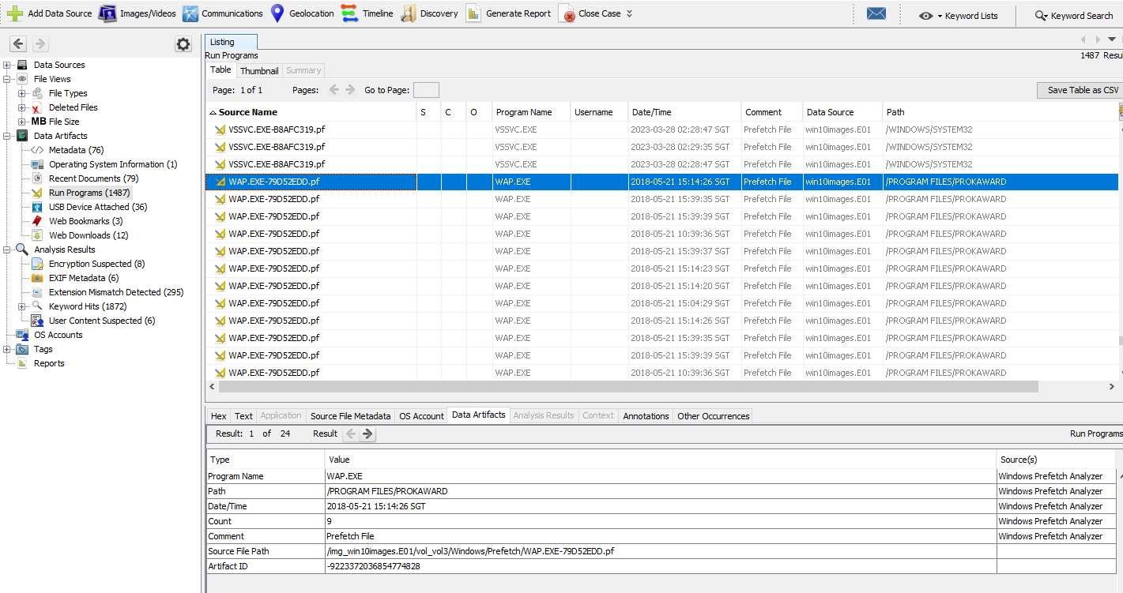

Figure 32 keylogger subprocess WAP.exe prefetch file

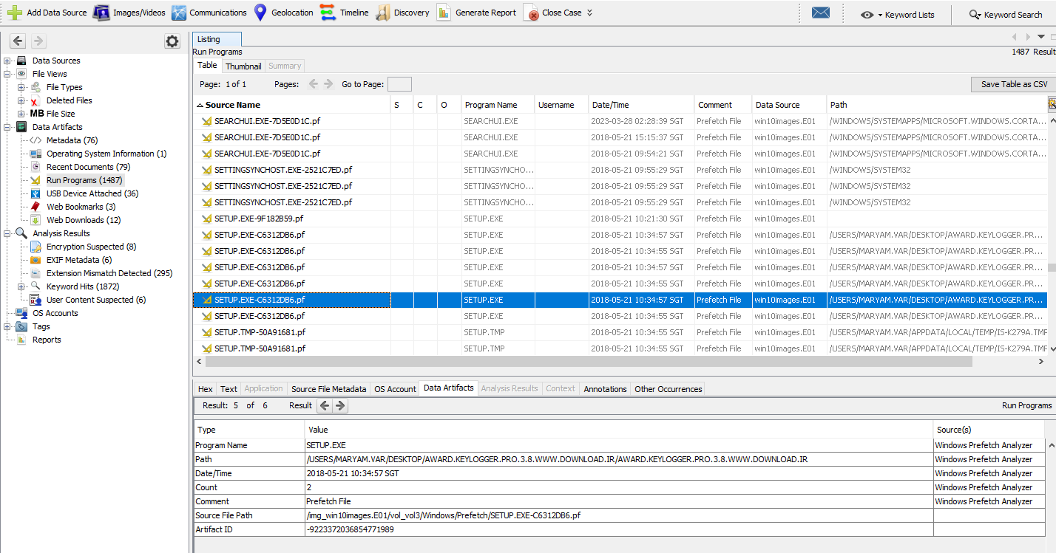

Figure 33 keylogger subprocess SETUP.exe prefetch file

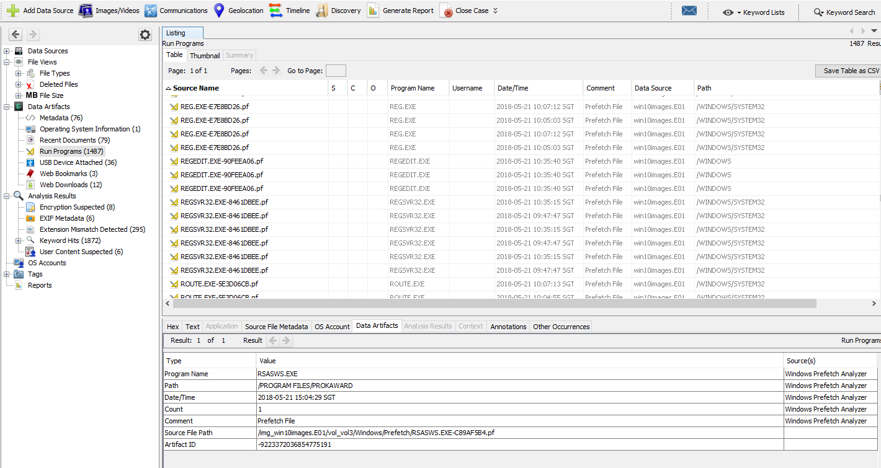

Figure 34 keylogger subprocess RSAWS.exe prefetch file

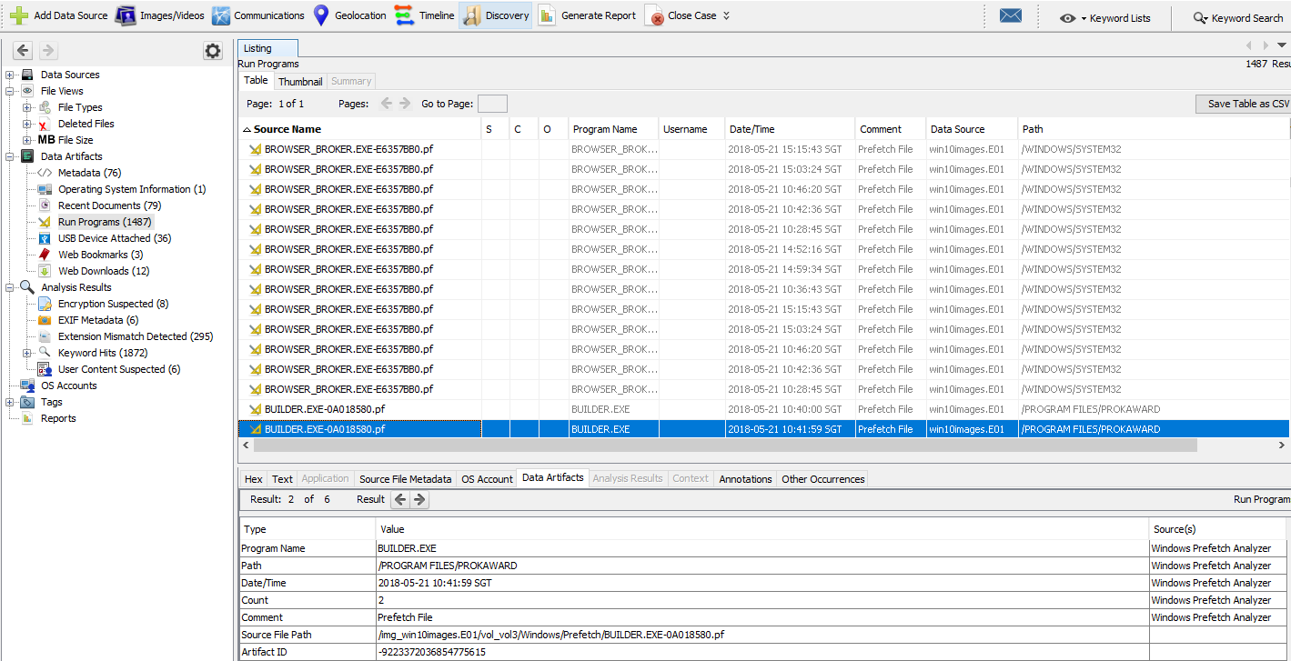

Figure 35 keylogger subprocess BUILDER.exe prefetch file

### KMSAuto

This software is called KMSAuto; it is found within Data Artifacts > recent documents and run programs and involves a subprocess called FAKECLIENT.exe. KMSAuto is a software that allows its users to conduct malicious practice, which is illegally bypassing Microsoft’s windows licence activation for a victim device. (Villanueva, 2023 ). According to the name of the download shortcut, it was most likely downloaded from a site called p30download. This could cause the device user to be charged with copyright infringement and software piracy.

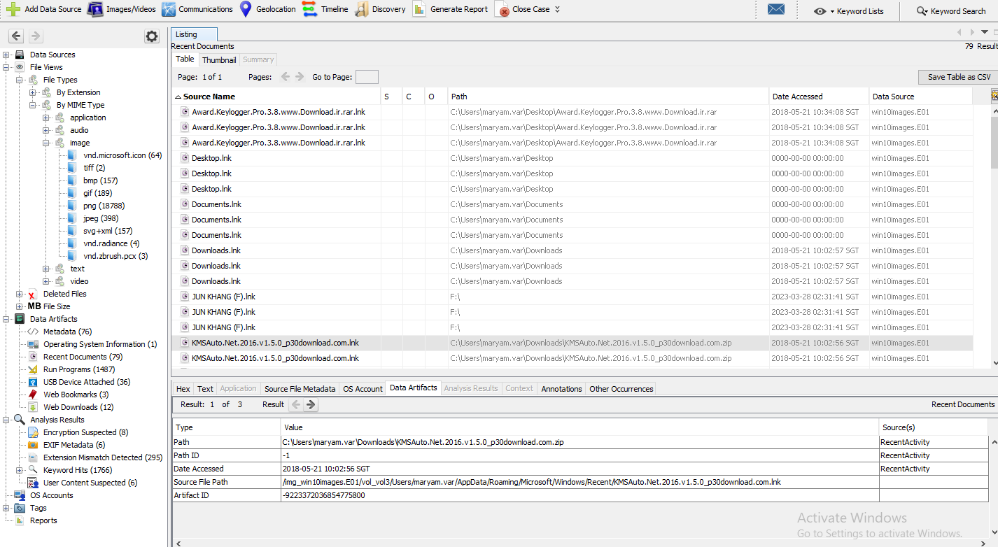

Figure 36 KMSAuto download shortcut.

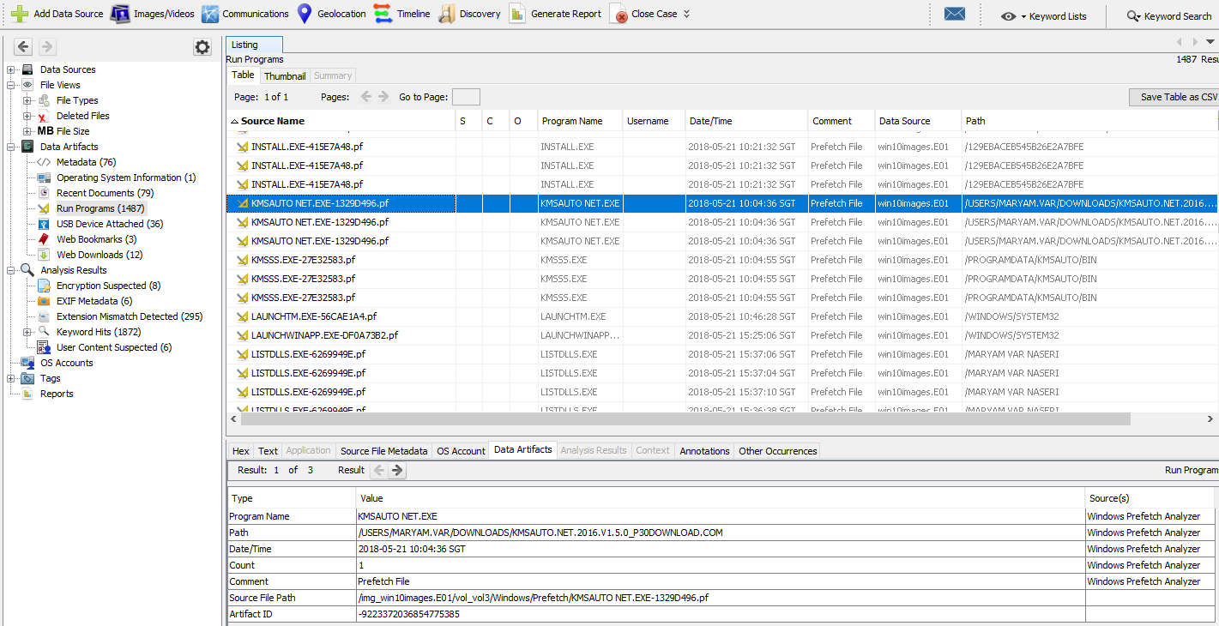

Figure 37 KMSAuto prefetch file

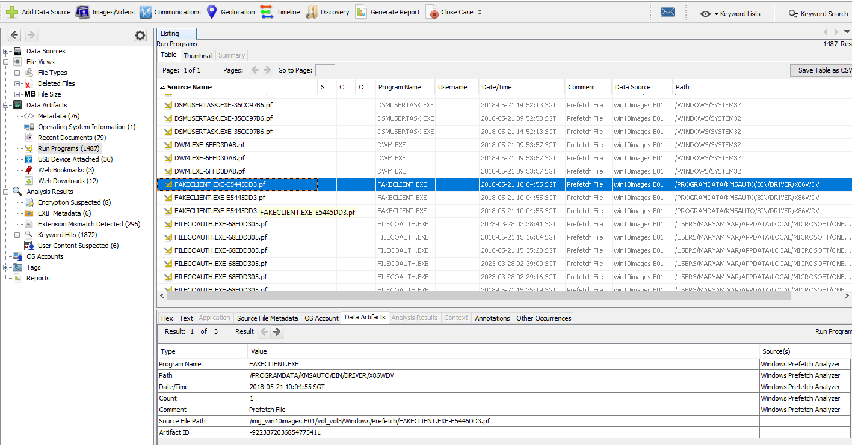

Figure 38 KMSAuto subprocess FAKECLIENT.exe prefetch file

### DLLInjector

This software has been found within data artifacts > run programs. DLLInjector allows an its parent application to introduce new data and functionalities into target processes within a software. It can be potentially used to bypass security measures and allow for unauthorized access to confidential information.

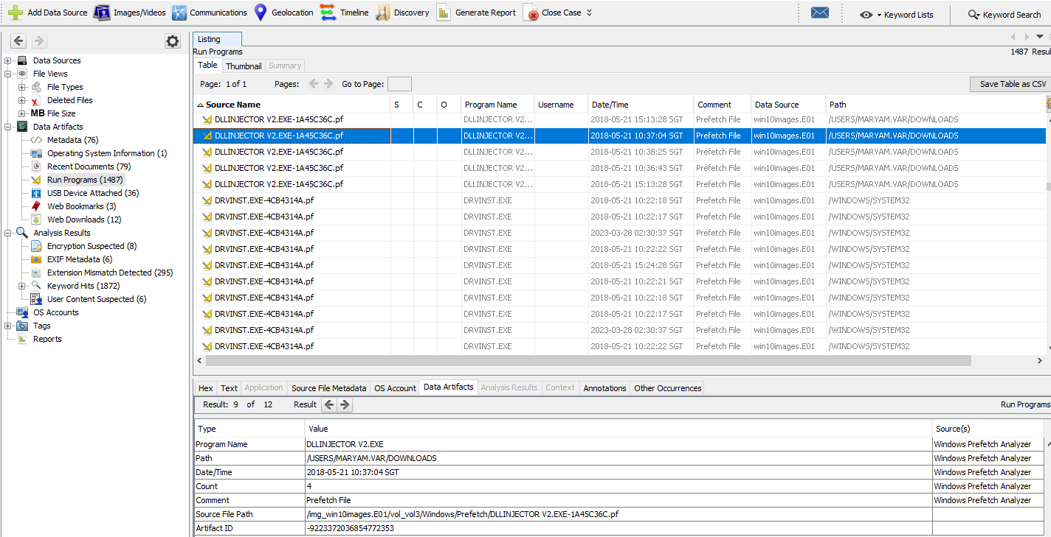

### Web Browser search

The investigation also has found evidence of the user searching for malicious websites. It found searches for malcode, a website that contains information on malicious websites and IP addresses. In addition, it also found searches for p30download. A very questionable website that contains both legal and illegal software to be downloaded by its user.

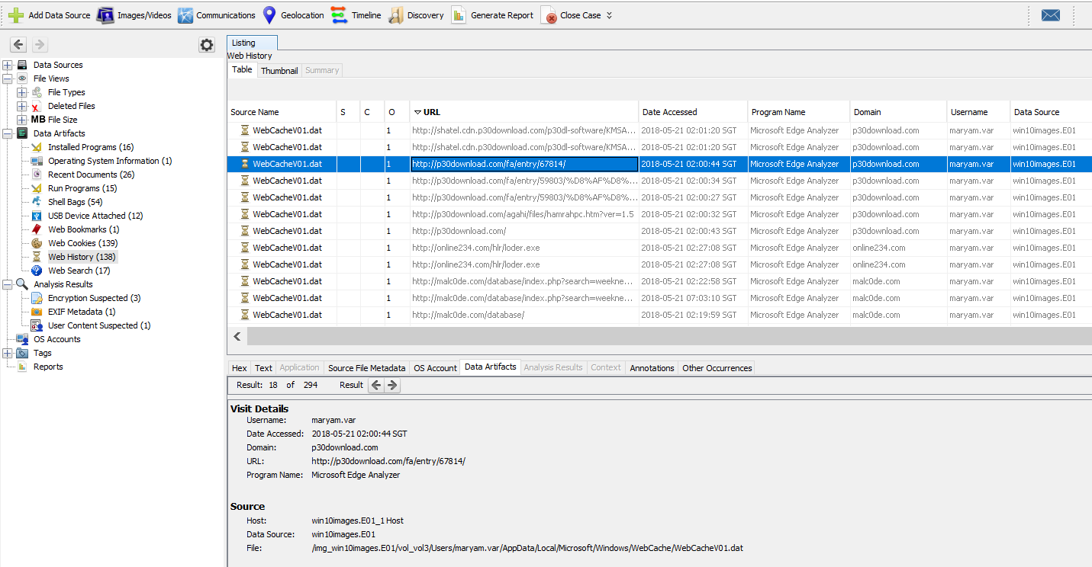

Figure 39 Microsoft edge web cache about URL leading to a specific entry in p30download

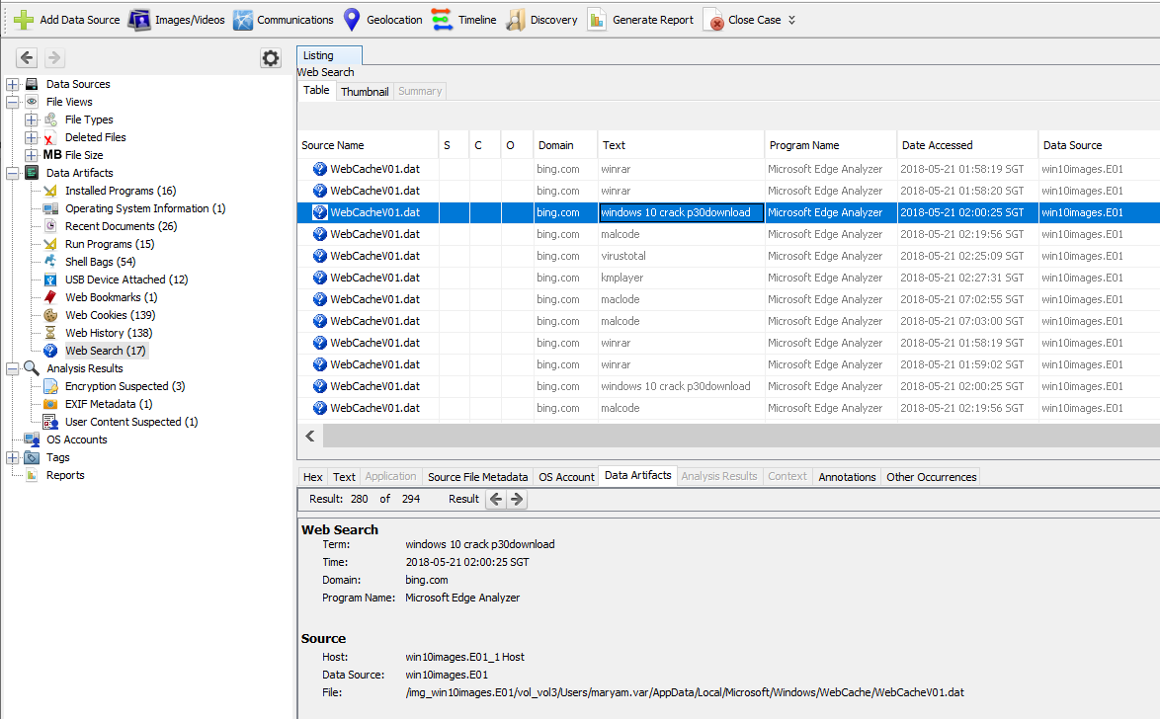

Figure 40 Search history about p30download

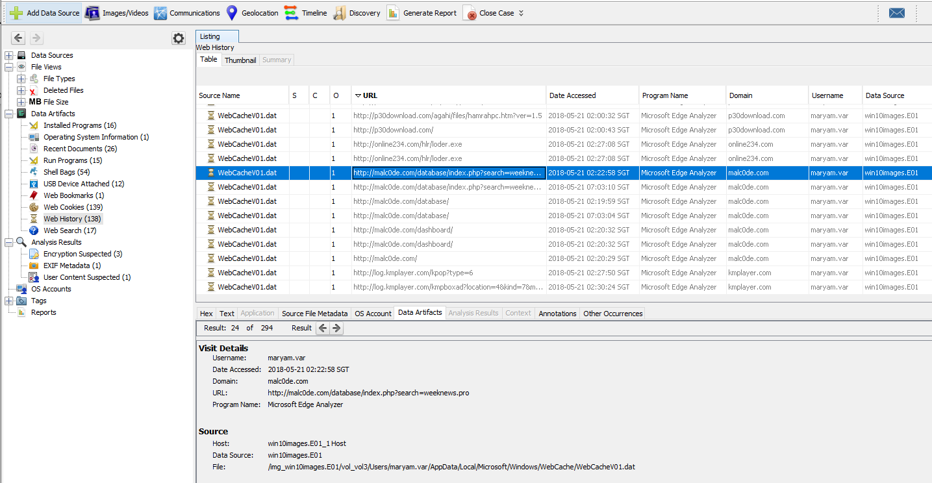

Figure 41 Microsoft edge web cache about URL leading for malc0de.com search results 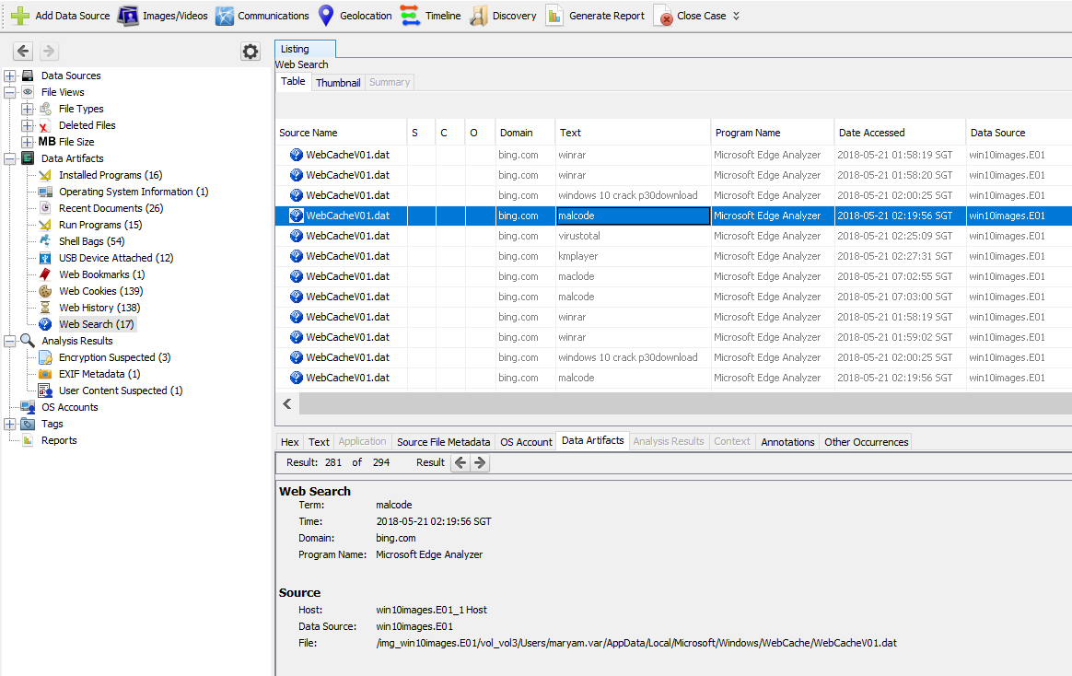

Figure 42 search history about malc0de

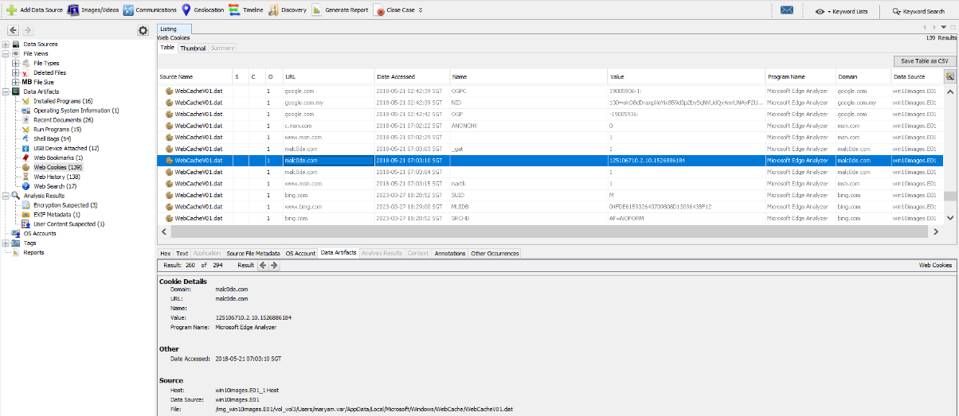

Figure 43 web cookies for accessing the malc0de website.

### RAM Image

By using various volatility commands, it can conduct a detailed analysis towards the RAM image. As different commands expose different components of the RAM image, it is possible to suspect malicious processes if given enough time and effort. The commands that are primarily used during analysis are:

* windows.pstree.PsTree
* windows.cmdline.CmdLine

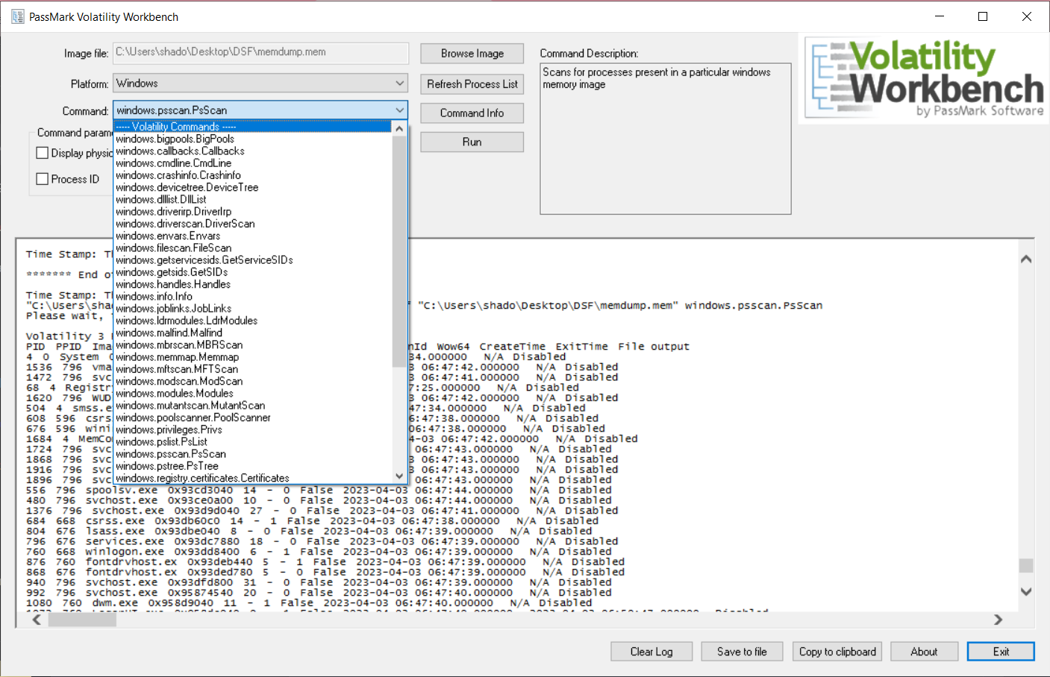

Figure 44 Usage of Volatility Commands

### RSAWS.exe

The process “RSAWS.exe” appears to be a child process with no specific description or information related to system processes, increasing the suspicion that it could be malware. In addition, the file itself is located under the folder named ProKAward, which is not a default windows system process. The file is also an executable file type, meaning that it can monitor or alter applications within the system.

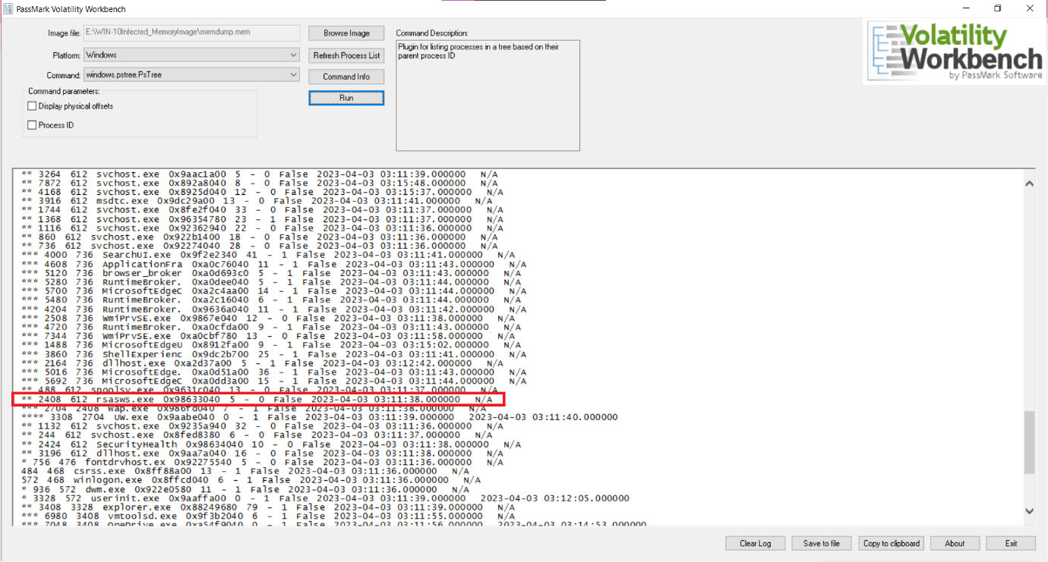

Figure 45 Presence of rsasws.exe as a child process

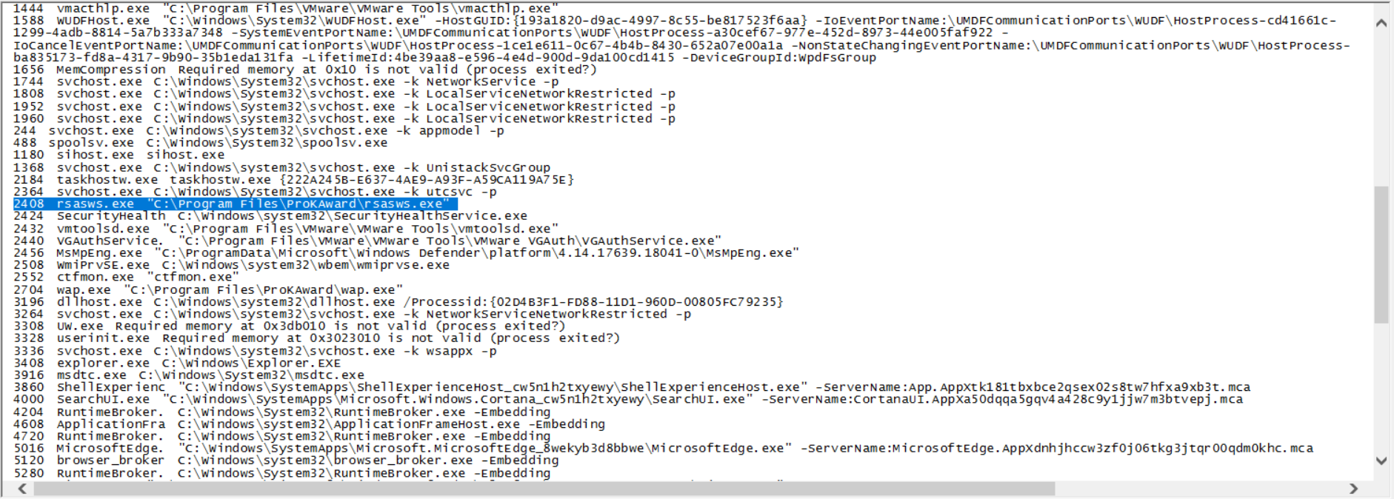

Figure 46 rsasws.exe is under ProKAward

### WAP.exe

WAP.exe shares the same properties of “rsasws.exe” being a unknown process within the system. It is under the process of “rsasws.exe”, which should be alarming as it can also be used to monitor or alternate the system as it is also an executable file.

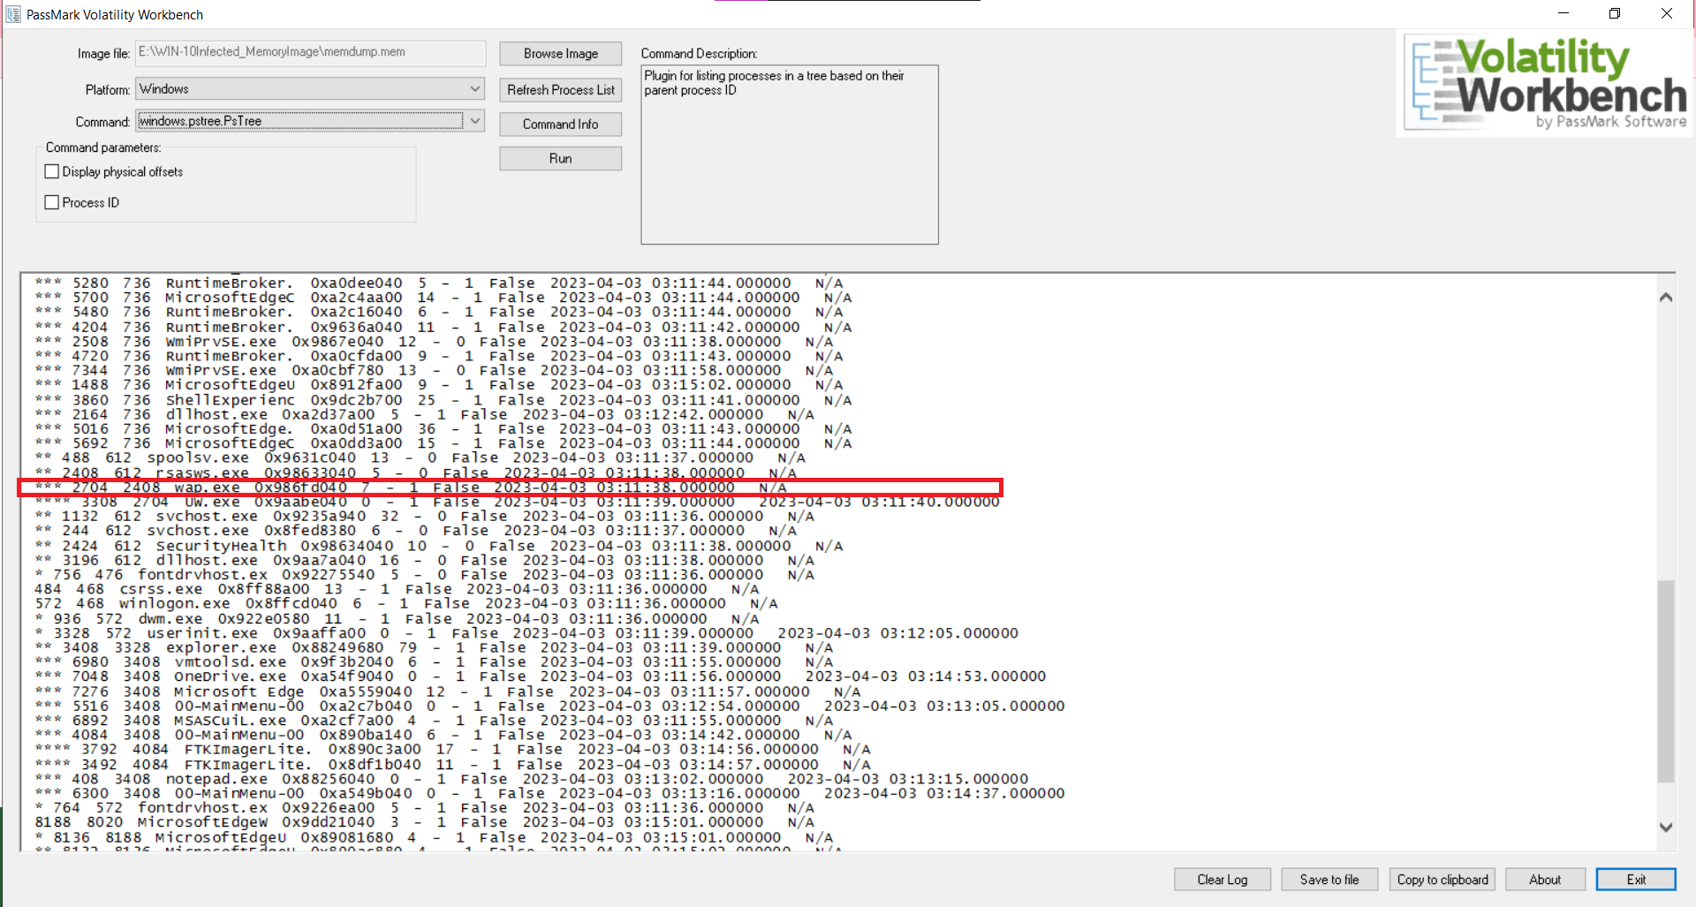

Figure 47 Presence of WAP.exe as a child process

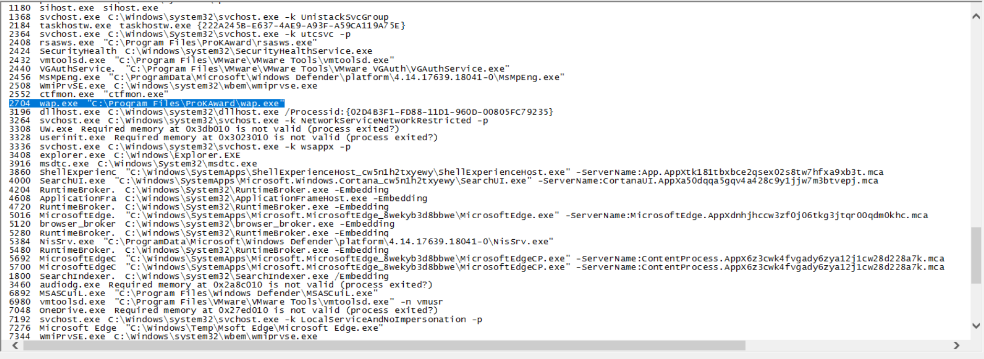

Figure 48 WAP.exe is under ProKAward

### UW.exe

UW.exe is also within the same branch of the previous mentioned suspicious processes. Without proper description or further information about the process, it is also determined that the mentioned process could also be suspected as malware within the system.

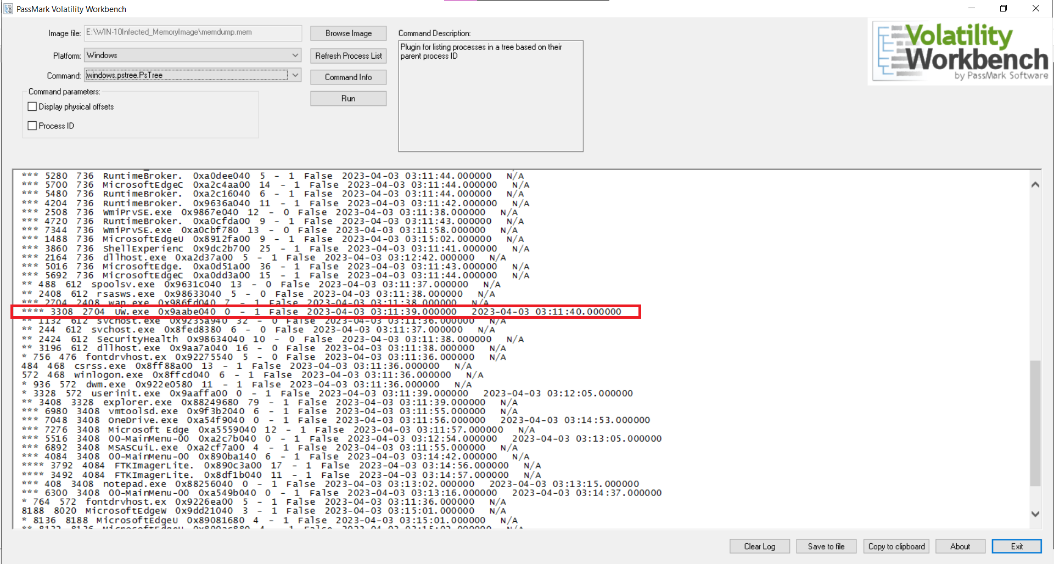

Figure 49 Presence of UW.exe as a child process

The processes that were considered suspicious are actually because the files are child processes and are under the same branch. Besides, it is under ProKAward and the naming is weird. The executable files that were mentioned are actually created and interacted when the trojan keylogger is activated. After some extensive research, ProKAward is a well-known trojan keylogger software that is used to track the device’s users’ keyboard input and attempts to disguise its processes.

A trojan keylogger, on the other hand, refers to a keylogger that is delivered or hidden within a trojan horse. A trojan horse is a type of malware that disguises itself as a legitimate or desirable program but contains malicious components. In the case of a trojan keylogger, the keylogging functionality is embedded within the trojan, which may have other malicious intents, such as stealing sensitive information, compromising user accounts, or facilitating unauthorized access to a system.

# Conclusion

As a result of the analysis done on Windows Server 2010 hard disk image using Autopsy, several suspicious activities that were found included Keylogger, KMSAuto, DLLInjector, searches of “malc0de” and “p30download” on the web browser.

On the other hand, results of analysis done on the RAM image using Volatility Workbench includes suspicious activities such as RSAWS.exe, WAP.exe, and UW.exe that are found under ProKAward folder, stimulating presence of trojan keylogger.

Overall, both analysis of the hard disk and RAM image conducted in this investigation has brought impacts such as knowing how to identify malicious activities by finding crucial evidence of malware existence Windows Server 2010. Besides, it could also help understand more on the extent of infection such as how vulnerable the system is to attackers and potential risks to system and data. On top of that, the analysis also assisted in incident response and future prevention where the findings of the analysis can be contributed as an incident response effort by sharing it to relevant security teams and organisations to help enhance their knowledge and prepare for similar attacks.

To cap off this report, the investigations conducted as stated above is only a tip of an iceberg. Some further investigations such as Network Traffic Analysis, User Behaviour Analysis, and Malware Reverse Engineering are also recommended. By pursuing these investigations, it could help contribute in enhancing security postures, strengthen defences and prevention against cyber threats.

# References

*Keyloggers: How They Work and How to Detect Them*. (2 2, 2023). Retrieved from crowdstrike: https://www.crowdstrike.com/cybersecurity-101/attack-types/keylogger/

*Trojan.KeyLogger.25094*. (30 5, 2015). Retrieved from Dr.Web: https://vms.drweb.com/virus/?i=3918754

Villanueva, S. (2 3, 2023 ). *What Is KMSAuto Net?* Retrieved from KMSAuto Net: https://kmsautonet.org/what-is-kmsauto-net/

# Appendix

## Workload Matrix

|  |  |  |
| --- | --- | --- |
| GROUP MEMBERS | TASKS | SIGNATURE |
| Ch’ng Khai Nian | INTRODUCTION,  RAM IMAGE,  CONCLUSION |  |
| Chin Hong Wei | RAM ANALYSIS |  |
| Chiu Wai Kin | REPORT |  |
| Ee Jun Khang | HDD IMAGE |  |
| Damon Ng Khai Weng | HDD ANALYSIS |  |